**ABSTRACT**

This project highlights the need in the Nigeria fashion industry for efficient tailoring services for traditional attire. I propose an online portal that allows clients to design clothing by selecting their preferred fabric and style. This process removes the apprehension from choosing fabric and dealing with tailors.

Tailors are notorious for their inconsistency and missed deadlines, but there are a lot of dedicated tailors in Nigeria. The challenge is getting to them because of constraints of time and location.

**Suave Stitches** identifies high-quality, dependable tailors through a rigorous process, and uses technology to make their services available to clients independent of the location of the client or the tailor.

CHAPTER ONE

**INTRODUCTION**

**Science**

Science is a discipline of learning which deals with measurable or systematic principles. It does not rely on intuition or natural ability. Science can be described as a body of knowledge that deals with established facts or the acquisition of these facts.

Science has come a long way from the times of Thales and Socrates to the smart devices we have today.

**Science and Technology**

Technology comes from the Greek word *techne. Techne* is the name for the activities and skill of the craftsman as well as arts of the mind and fine arts. Associated with t*echne* is the idea of bringing forth or making things. Today this idea extends to industrial processes and crafting of goods of every kind. Tailoring is situated in this aspect of craft, which is taking a piece of fabric and turning it into clothing of different types.

Technology broadly can be described as applied science or the practical application of knowledge, so it is the point where science comes alive. For instance, after research is done to find active natural ingredients that can inhibit the spread of a certain bacteria in the body, this active ingredient is then synthesized in the laboratory so it can be mass produced for greater good and also for profit. The whole process is underpinned by science. So we can see that science enhances lives and also provides personal benefit to the custodian of certain knowledge.

Technology alters the way humans relate with their environment. It offers a means of controlling some aspects of the environment and this enhances the survival of the human species.

**Science and Technology in Africa**

It is true that Africa played a pivotal role in the historical development of science. The Egyptians had elaborate systems for mathematics and trigonometry. T, this was essential to the building of the pyramids. The Yoruba and Benin kingdoms in Nigeria had civilization with clear leadership and matured societies.

Egyptians charted the movement of the sun and constellations and the cycles of the moon. They divided the year into 12 parts and developed a yearlong calendar system containing 365 ¼ days. Clocks were made with moving water and sundial-like clocks were used.

**Technology in the 20th and 21st Century**

Technology advanced so much in the 20th century that today what we expect of technology would be considered outrageous by learned people from the 19th and early 20th century. There are faster and more reliable modes of transportation. Advances in agricultural science means a lot of the world’s population can get by without been involved directly in farming. In the past almost everyone was involved in agriculture, because there is a limit to the amount of land that can be cultivated by anyone the returns on the amount of time invested was limited. With the rise of farming machines, farms that stretch over the thousands of hectares can be run by a handful of individuals. There is a reduced chance of famine (Wikipedia.com) because, today if there is massive crop failure in any geographical area, food which has better storage now can be imported, whereas in the past there was barely enough to spare, no mode of transportation and ineffective storage method.

Standard of living which is a measure of the level of wealth, comfort, material goods and necessities an example is the average life expectancy of the world in the 19th century which was about 40 years for men and 43 for women(Wikipedia.com). Today it stands at 70 years for men and 72 for women (Wikipedia.com), this is made possible because of the advances in medicine, reduced risk of terminal infectious diseases due to better sanitary products and safer work environments.

The most notable improvement in technology of the 21st century is the rapid advancement in computer, fuelled by the invention of transistors, thus making computing devises smaller and powerful. This lead to the rise of the portable computing devices like laptops and smart phones, and the internet which has become so critical for business and individuals that people can’t imagine what life was without it.

**Technology and Business**

The internet has changed the way business is done, it has brought in new players in most industries, and killed off old ones that failed to adapt or adapted slowly. With your internet connection you can work from anywhere in the world, communicate with people half way across the world without having to set up expensive infrastructure we have tools like Skype, Google Hangout. We also have project management tools like Basecamp and Smartsheet.com, where remote workers can log in at the beginning of their day (usually due to time-zone difference) and checkout tasks that have been assigned to them for the day by their managers. This of practical implications for Suave Stiches, because physical contact with the tailors to hand the fabric to them will be inefficient and costly. Since most tailors are located close to huge markets, the system can pass orders to them by email, and then their apprentices pick the fabric from partner fabric vendors.

**Technology, business and Nigerian tailors**

The rise of the remote workers is accelerating, instead of companies employing unskilled workers for jobs that require little training, and incurring huge overhead along the way, the company outsources the job to contractors who are paid by the hour. This style has become widely used because it is considered to be cost effective and flexible: firms only pay for the services rendered and no more. Outsourcing jobs can also increase the pool of talented workers available to anyone that require such services, for instance, most Nigerian banks have their web interfaces built in India or other countries where they have a huge pool of advanced technical workers.

With an app built by a freelance developer, you can assemble freelance workers, from data entry clerks, accountants, to business developers and virtual assistants. With this you can quickly test your business model/idea to see if there is a market for it, from there you can build out a standard company, or you kill it off if you don’t gain traction, without having to deal with huge rent, and loads of legislation, laying off staff is as easy as clicking a button to end contracts over the internet.

In the technology industry, the implication of virtual workers for businesses of any size is profound; by sharing the service of highly skilled workers they hence share the cost of such highly specialised skills and still get quality services.

Suave Stitches will benefit from this new system because rather than employing tailors, and dealing with all the issues mentioned above, we leverage on the existing infrastructure that the tailors have and offer them a better way to increase their income and grow professionally. This is in line with the spirit of remote/contract workers, who are expected to provide their trade, while their employers worry about only their pay.

CHAPTER TWO

**PRODUCT**

**The Problem**

Sometimes we all need bespoke outfits for special occasions. This is especially true for Africans, who like to show their deep cultural heritage, rich background and history. No matter their place of residence around the world, they like to have specific garments available, just as they long for traditional meals even in the Diaspora. I have knowledge of a hair stylist in Nigeria recording her work on video that will be sent to London, so it can be replicated by another hair stylist over there.

In Nigeria, especially Lagos, most professionals are short on time; they have to deal with heavy traffic to and from their destinations it is estimated that Lagosians spend 4 hours on commute daily (V-Park Management Solutions Survey Report, 2013). This situation means less time to spend with family and fulfil other social obligations. The Nigerian middle class is 40 million people strong, and they have disposable income (World Bank, 2013).

This class of people are the demographic that is targeted by Suave Stitches. They have disposable income, but lack the time. We all know how online grocery shopping saves time and resources that is the same convenience that we offer. Make a direct comparison to an existing online grocery here.

**Attending an occasion without the right attire is frowned upon**

**1** Muslim wedding bride girls, Nigeria

**2** Yoruba traditional wedding, Nigeria

Most people have no choice but to deal with this tailors or fashion designers, because all the occasions and ceremonies attended by Africans have very specific guideline or expectation on the outfits to wear. Also in most African cultures, social status is directly tied to your clothing guests at an event will be seen as anomalies, if they show up with outfits outside the recommended style and fabric.

So everyone has no other option but to keep trying different fashion designers, with different results.

Given the rowdy nature of most Nigeria’s markets, it is usually an unpleasant place to visit. There is nothing like leisurely browsing the aisles because they are disorganized. Most people only make trips to the market for very important reasons.

**The entrance to a typical Nigerian market**

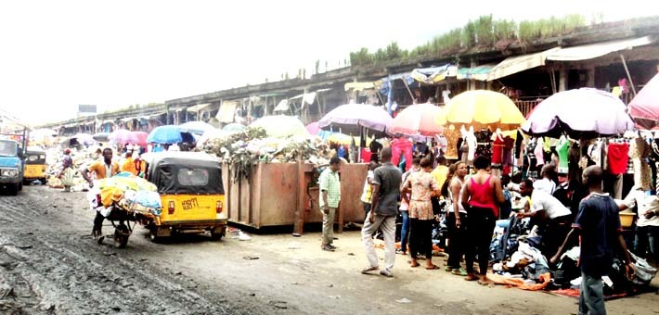

Most individuals have been burnt by these tailors and have mostly given up on local tailors. However, the skills and knowledge of the tailors are unique and cannot be replicated by industrialized processes or foreign designers. The tailors are highly sought after because of the personal nature of making clothing, the process of becoming a tailor is very informal and the skills is passed down through an apprenticeship process. The fashion design field is dynamic, so they have to learn new styles all the time. All these factors make the process more delicate than imagined by outsiders. Hence bad contracts, limited number of tailors and protracted skill acquisition process

Clothing plays an important role in Nigeria’s culture and society.

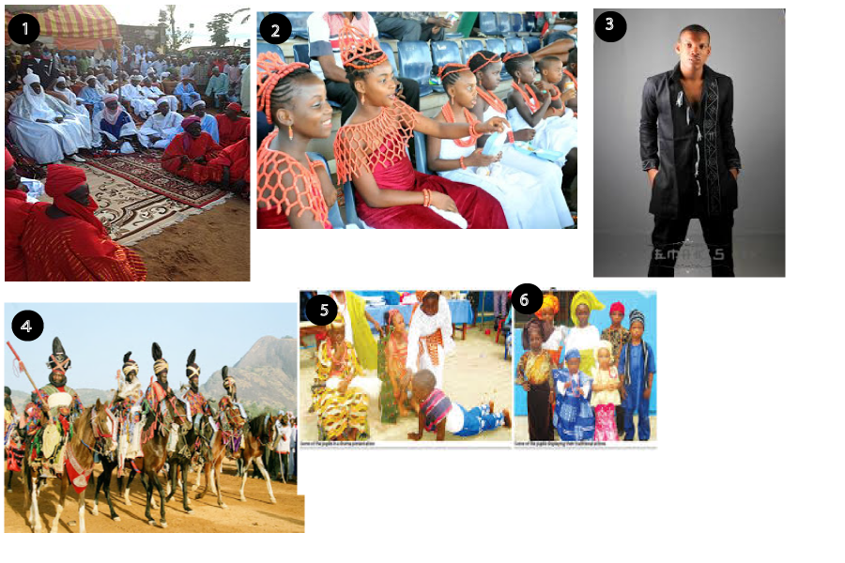

1. Emir of Muri and his viziers, Adamawa Nigeria

2. School children showcasing the attire of Benin people, Abuja Nigeria.

3. Modern Nigerian traditional attire.

4. Traditional warriors, Sokoto Nigeria

5. Children acting a play dressed in traditional attire.

6. Children showing Nigeria’s cultural diversity.

Speaking of getting a good tailor is a shoot and miss experience. Due to lack of strong laws, there is little relief for contracts gone sour, getting your money back is not worth the effort, and the fabric is wasted. Prospective clients of these fashion designers ask around for recommendations. This informal way of getting recommendations is not helpful as it can be biased. When they do get the reviews, and settle for their choice of tailors, clients have to deal with the same problem that made them ask for recommendations in the first place.

**2.2 Market Analysis Summary**

Based upon the points made above about the ever-present demand for bespoke clothing, I believe there is a market to capture here. It is part of culture in Nigeria that almost every woman from the Southern part of Nigeria buys very large boxes immediately after her wedding. This box serves as a repository of traditional clothes that will be acquired going forward. This demographic is huge, and they are not the only ones that need this service, Traditional fashion is steadily rising in popularity in Nigeria. This is happening because of the realization that Nigeria’s problems cannot be resolved by imitating solutions that worked in the west.

The following are some of the reasons for using an online platform for tailoring needs.

* It comes with a Fabric section to pick desired fabric.
* It is a one stop shop for all fashion needs.
* Transparency of design process, hence peace of mind.
* 100% Money back guarantee that is unavailable elsewhere.
* Flexible delivery, no need to visit tailors regularly to ensure that your order is being fulfilled.

**The Solution**

Suave Stitches will offer fabric and tailoring services online, the services can be broken down into the following:

* Selection of preferred fabric
* Selection of desired style
* Delivery

Basically, a web interface as the front end, to do the following

1. Enable clients select their preferred fabric, if it is available.
2. The option of providing their choice.
3. Give them a wide choice of styles to choose from.
4. Have the option of requesting bespoke design.
5. Providing a medium to take body size measurement.
6. Give estimated time of completion.

**Elaborating on the above points**

1. There will be a few partners (sellers of fabric), that we can catalogue their inventory. And have that on the website along with thumbnails, descriptions of the texture and other things. So clients can make an informed choice that meets their expectations and requirements.
2. Provision will also be made for clients who require specific services, like those going for uniforms to be used for ceremonies, the fabric will be arranged to be delivered to the tailor through a courier service.
3. A collection, in pictures of the most popular styles of the day, and with popular retro styles that are still cool. This will be combined with some offbeat styles for those that prefer such styles.
4. If the preferred style of a client style is not available in the database for any reason, the system will be flexible enough to make provision for such clients by allowing them request custom styles. They can upload pictures of the style, along with descriptions and references to other styles.
5. Body measurement is very necessary for this system to function properly; the default measurement will be international sizing charts for men and women. If the chart is not adequate, there will be instructions on how to take personal size measurements. Standards required for clothing include, top of shoulders, bust, waist, hips, inside legs and calf.
6. Estimated style of delivery will be calculated by the system after an order is processed by our algorithms. This will happen instantly and will be based on pre-existing orders. Optionally clients can choose our premium service that pushes their order to the top of the queue. Delivery for the premium services will range from two working days to five.

**CHAPTER TREE**

**METHODOLOGY**

A critical assessment of the features shows that the system’s building blocks will be similar to an online shopping store, howbeit a more complex one

The table below illustrates the similarities.

|  |  |
| --- | --- |
| **Store Shopping Store** | **Tailor System** |
| Select choice of product | Select choice of fabric |
| Select choice of colour or size | Select preferred style |
| Choose preferred shipping method and get estimated time of arrival | Get estimated time of delivery |

The differences are as follows

1. The clients decide that they want to use fabrics they bought, hence triggering the module to have fabric delivered to us.
2. When the required measurement for the client is unknown, they might have to source for it manually by physical measurement.
3. The method of calculating the delivery date is complicated because we have to consider the orders that are at hand, unless there is kind of an express service, although the commitment for that will be quite daunting.

The new programming concept that I have learnt over the past quarter, talks about breaking down your problem into smaller units, then find out is those smaller units have been solved by others. If solution is available or open source there is no need to reinvent the wheel, just incorporate it and then go on to solve the custom problems you have. This approach makes sense, it is a waste of effort to build everything from scratch, and you might get distracted with the minor details and miss the bigger picture. That will be the approach to building this tailoring system, faster development time means you can start testing the idea quickly.

**Investors**

The developed countries have done a good job in trying to harness the benefits of technology, but lately Nigeria is rising, we do have a co-working space (CC-Hub) with a technological flavor. That was unthinkable in the past, and foreign investors are taking note of this progress.

Recently there has been a lot of clone of foreign apps and technology business models in Nigeria, the prospect of success for such products are at best slim. Nigeria and her people have a different historical experience from the countries where these products were designed. The solution to problems or entrepreneur endeavors should take into account the socio-cultural values of the people. Socio-cultural factors can influence both positively and negatively entrepreneurial emergence in a society (Rahma and Farhana 2014).

Technology should not be the first or default tool in the box of solutions to consider, in an attempt to solve any problem in the Nigerian society, sometimes an awareness campaign calling for attitudinal[1] change will suffice. After proper assessment, if the solution to a problem lies in the use of modern technology, then rather than directly applying solutions that worked in other geographical regions, care should be taken to first adapt those solutions to fit the values and lifestyle of the local populace (Rahma and Farhana 2014).

Suave Stitches is the product of diligent analysis, after identifying a problem care was taking to ensure there was no haste to rush to technologies tool box for a solution. Other solutions were considered including attitudinal change of tailors before settling on a technological approach to the problem.

Some savvy entrepreneurs already recognize this reality. E-commerce sites like konga.com and jumia.com who are the pioneers, introduces payment on delivery to address the issue of trust and bad contracts, their customers have the option of opting to pay at the point where they receive the goods. This approach is laudable because, as stated earlier sour contracts are difficult to resolve, so instead of the client being responsible for receiving the goods from the time it leaves the e-commerce company’s warehouse, a transaction only occurs at the point of reception, every other activity by the buyers are treated as showing interest.

The following are potential investors:

**The Tony Elumelu Foundation:**

The founder Tony Elumelu is a Nigerian businessman turned angel investor.His foundation is currently running a programme that encourages entrepreneurs to apply for funds Africa-wide. The programme runs for two months and ends in March. There is no limit to the kind of ideas that will be accepted. I believe this project is a good fit for the kind of ideas that is needed that is solutions that were conceived as a direct consequence of the challenges facing our immediate environment.

**iDEA Nigeria:**

IDEA (Information Technology Developers Entrepreneurship Accelerator) provides essential support to entrepreneurs to build software skills, solutions and businesses critical to their success. Entrepreneurs accepted into iDEA receive support in the way of physical work spaces, shared facilities, training, mentoring and access to capital.

Since Suave Stitches is a technology driven business, which uses cutting edge software development practisesto solve a pressing problem in the Nigerian fashion industry, this program is an excellent platform to nurture the business.

**Social implications**

An indirect consequence of this product is that it has the potential to increase the expectation of what clients can get from their tailors. This will be more profound in the urban areas where people are more tech savvy and where the product will have maximum exposure. This will be a desirable development, since it wouldn’t hurt to get better value for your money. Also it can leverage on Nigeria’s growing e-commerce experience, it will be a smooth transition for those that already shop online while attracting others who hear about the experiences of their acquaintances.

**Challenges**

1. **Tailor insincerity**

Nigerian tailors are notorious for their unreliability and known for their dishonesty. “Most, tailors view their job as ‘WORK’ thereby carrying it out in very bad ways, like not keeping to agreement/disappointment, shoddy work, missing fabrics, very poor finishing etc.” (Emenike 2014).

Tailors being the focal point of this system make this the biggest challenge faced. Getting them to sign up for the system and to deliver on time would be a challenge. One way to go about it would be bargaining power we have, that is the prospect of the large number of client which will mean continuous business relationship with the tailors. In other words the possibility of regular contract will be an effective tool to ensure they strive for perfection.

1. **Unawareness of technology’s benefit**

Although Nigeria has a high penetration of mobile computing devices, there is little knowledge of ways to leverage technology for personal development and economic gains.According to David (2014), “most Nigerian businesses lacked internet presence the best way to reach out to customers in this information age”.

This will be an impediment to any technology company. The way out is to do your best and wait for technology to gain root, for people to learn to trust it, and see its tremendous benefits.

**CONCLUSION**

There is promise for this project, like most idea or solution it will be slow to gain traction, but with time things will smoothen out. There is so much potential in the niche and demand is inexhaustible.

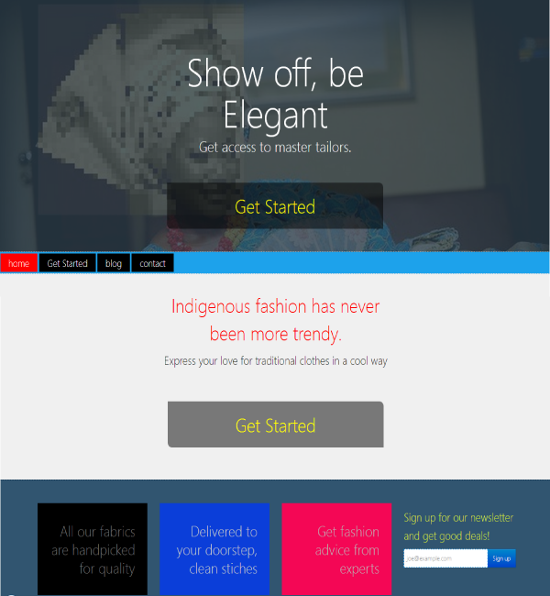

**REFERENCES**

1. “Famines in Europe”, Wikipedia, 2014, Web.
2. “Life Expectancy”, Wikipedia 2014, Web.
3. V-Park Management Solutions Limited Survey Report 2013
4. Nigeria Economic Outlook, World Bank 2014
5. Endy Emenike “How Tailors Can Change Their Attitude And Make Millions” ,WealthResult 2014 Web.
6. Fashioning Africa: Power and the Politics of Dress – Jean Allman 2004
7. David Anebgu “Online Advertisement in Nigeria”, total-facts-about-Nigeria 2014 Web.
8. Socio-Cultural factors influencing Entrepreneurial Activities. A Study on Bangladesh Rahma Akhter, Farhana RahmanSumi 2014.
9. “The remote entrepreneur running a successful business from the middle of nowhere”, Smallbusiness 2013 Web
10. “Tony Elumelu Entrepreneurship program”, Tony Elumelu Foundation 2014 Web.
11. “Nigerian tailors share your experiences”, Nairaland 2012, Web.

1. The National Orientation Agency of Nigeria recently launched an initiative called ‘Do the right thing: Transform Nigeria’. According to the Director of the Agency Mike Omeri “This is a moral reawakening program that will galvanise the people to greatness which lies in the right attitude”.